**Ganpat University**

**Faculty of Engineering & Technology**

**Computer Science & Engineerin0067**

***Name:- Dwij Vatsal Desai***

***Sem:- 2***

***Sub: - BOSS***

***Enrollment No.:- 23162121027***

***Prac:- 12***

**Practical 12**

1. Set your system clock in such a way that it is NTP client of classroom.exaple.com and verify the same

***Command:-***

sudo systemctl enable chronyd

sudo systemctl start chronyd

sudo vi /etc/chrony.conf

sudo systemctl restart chronyd

Chroync sources

Chroync tracking

timedatectl

in chrony.conf:-

server classroom.example.com iburst

***Image:-***

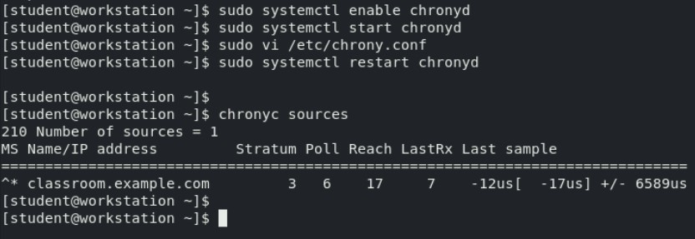

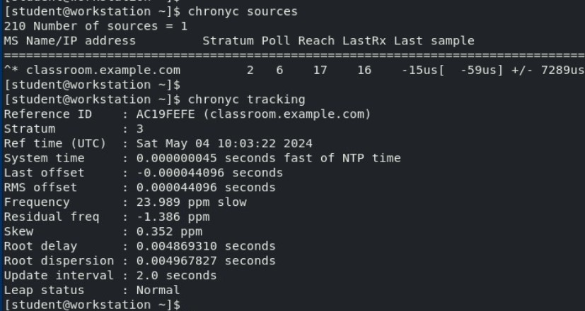 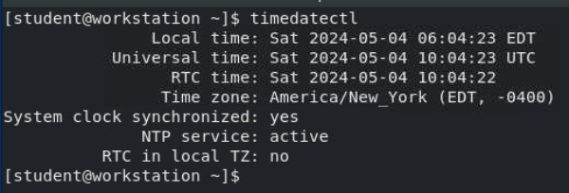

In chrony.conf:-

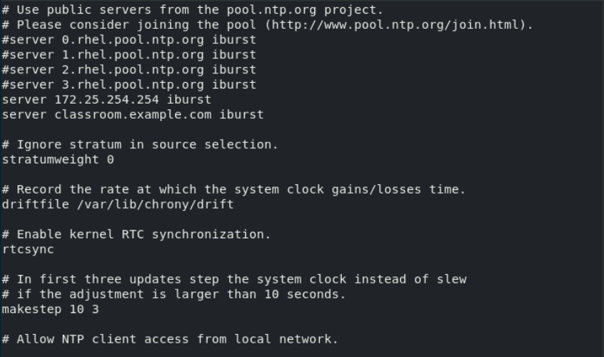 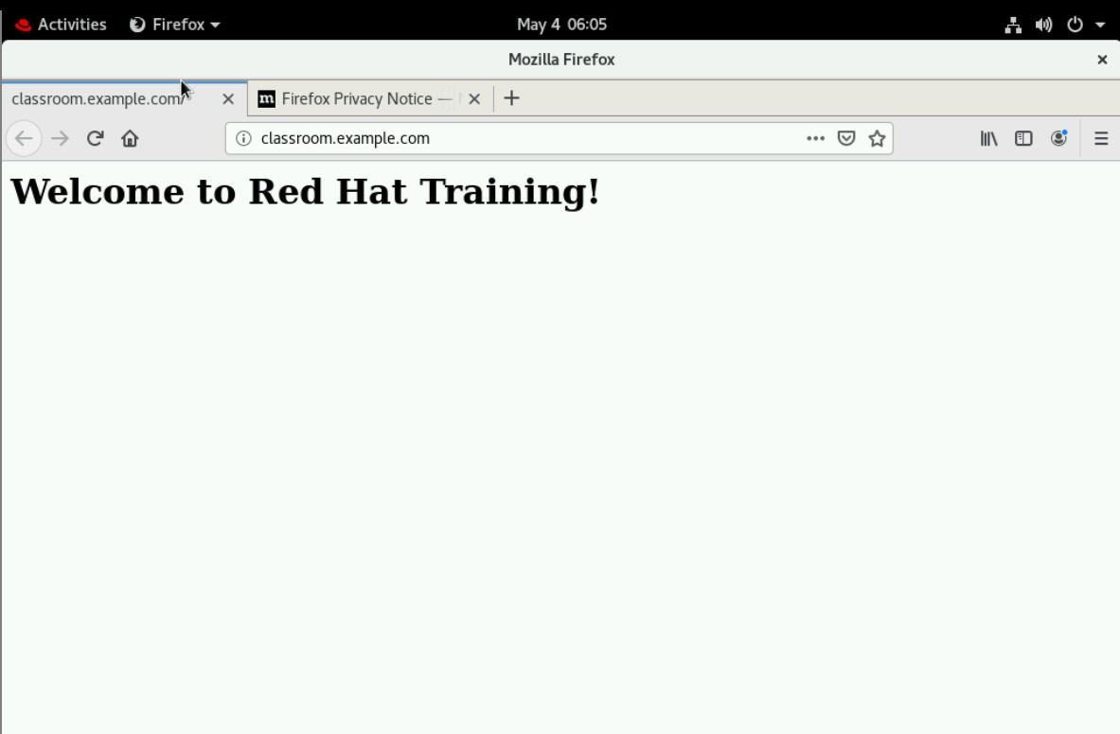

1. Create an archive of /usr/local directory and compress it as /root/yourname_surname.tar.xz

***Command:-***

pwd /

Cd /

Sudo tar -cvJf /root/DWij.tar.xz /usr/local

***Image:-***

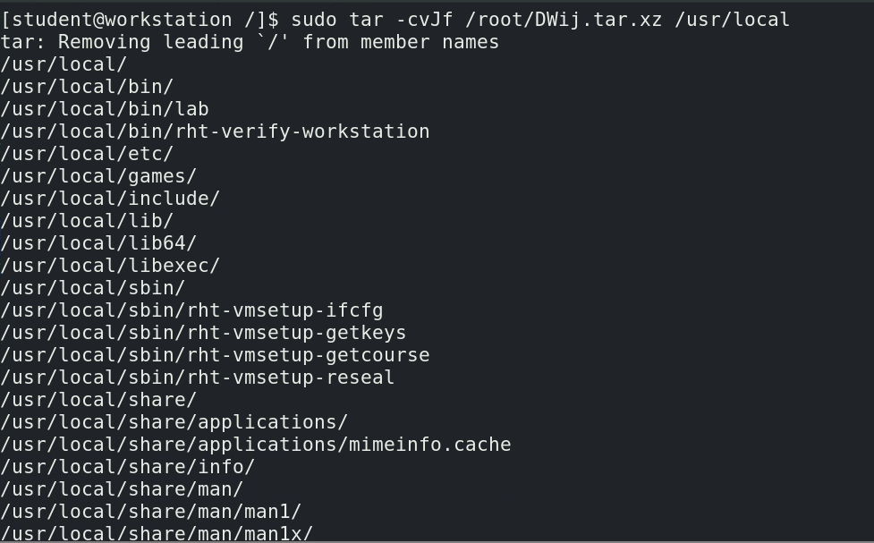

1. Display the list of directories/files present inside the compressed file

***Command:-***

Tar -tvf /root/DWij.tar.xz

***Image:-***

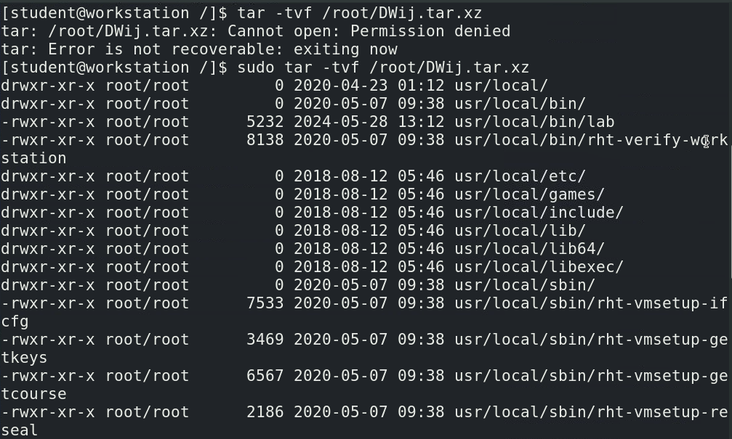

1. Extract the compressed file in such a way that the names of directories/files must be visible while extraction.

***Command:-***

Tar -xvf /root/DWij.tar.xz

***Image:-***

